# Strategic and Twitch Skill: Strategic – Terrorist Takedown: Bomb Beatdown.

## Game Premise

In this session we were given the task of either creating a Strategic game based around a team of players having to defuse a bomb or a Twitch skill game based around the players using social media to source information.

My team decided to develop a strategic game. The players task was to defuse a bomb using a total of twelve cards and working with other players.

Players receive three cards at the start of the game that will decide what the bomb would be made up of (see Fig 1), which would then dictate later on what tool cards the players would need to acquire and use to defuse the bomb (see Fig 2).

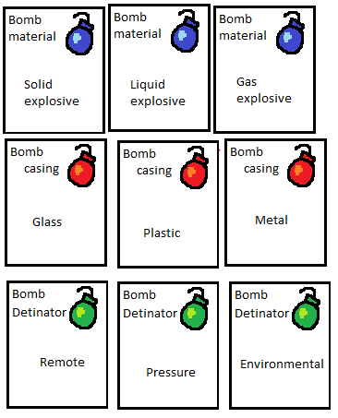

Fig 1, Bomb Cards.

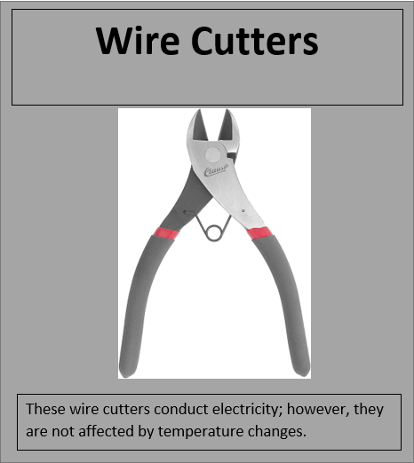

Fig 2, Tool Card.

The players have 10 minutes from the start of the game to defuse the bomb or they lose the game.

## Material used to make the game

We made the components for this game digitally, through the two software systems, ‘Paint’ and ‘Tabletop Simulator’.

If this game was mass produced the game board would be made on a clipping board with the design printed on top to have a high-quality durable finish and all game cards would be printed onto gloss card stock to have a high-quality finish.

## Rules and Mechanics

* Draw three cards to see the attributes that will make up the bomb,
* Draw three cards for each player from the defuse tool pack,
* You can only hold three cards at a time,
* Players can discard cards to try and draw new ones,
* Players will need to decide amongst themselves and discuss what tools they will use at the end of the game to defuse the bomb,
* Each player can only use one card at the end of the game.

## How the game is played.

At the start of the game three cards would be drawn, these three cards will decide the attributes for the bomb that requires defusing for example, ‘Liquid explosive’, ‘Metal’ and ‘Environmental’.

Once these cards have been drawn for the bomb descriptor, each player will draw three cards from the ‘toolbox’ which will give them a tool that can be used in order to defuse the bomb for example ‘Wire cutters’.

The ten-minute timer will then start and players will have to spend time discussing which tools would be best to defuse the bomb, during this discussion period players can dispose of cards and pick up new cards from the ‘toolbox’ but they are at risk by doing this as within the ‘toolbox’ there are chance and disruption cards which result in actions such as ‘-2 minutes’ and ‘Attribute changes’ these cards can drastically change the came and apply more pressure.

The players need to make sure the bomb is defused before the 10-minute timer goes off in order to win the game.

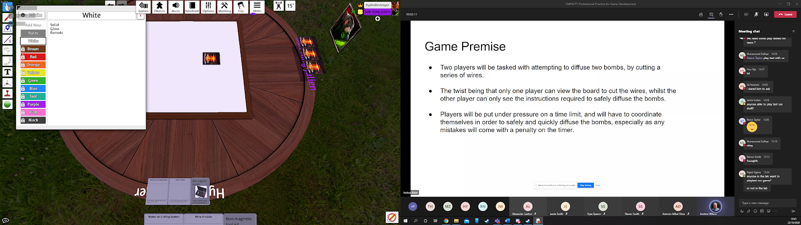

Fig 3, Game Play on ‘Tabletop Simluator’.

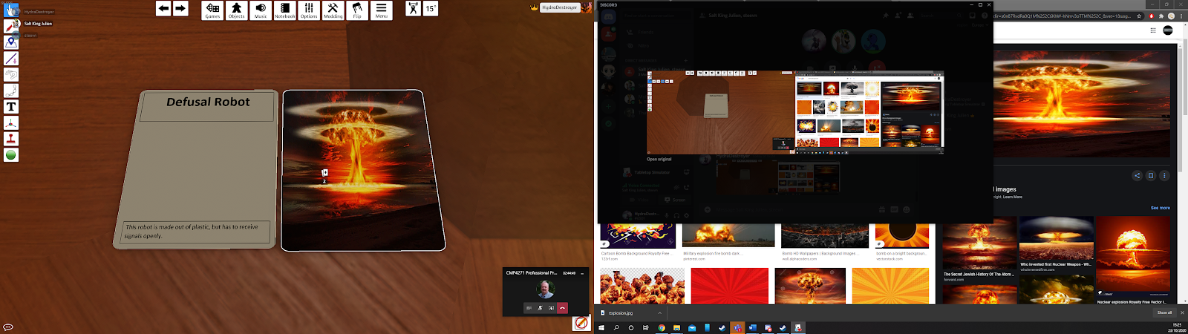

Fig 4, Cards Rendered on ‘Tabletop Simulator’.

## Play Testing

During play testing the design team was able to play together using Tabletop Simulator. The game functioned somewhat successfully but we quickly found out as a team that there were too many cards so we decided to remove some from the deck (but I personally thought we needed to add more cards to the deck). We also found out it was rather easy to figure out which tool cards were needed to be used based on the descriptions on these cards, therefore we decided to alter the descriptions on the tool cards in order to allow for more investigation from players.

## ­Experience working in the team to problem solve.

In this team I believed we worked well together but we all had our own versions of the game in our heads which lead to use wanting to solve problems in different ways. Due to the fact we all had our own ideas this resulted in no member really taking the lead in the decision making to finalise which ideas to carry forward into the game development, resulting in some members not being 100% satisfied with particular aspects of the game – for example how I wished we added more cards to the game rather than removing cards.

## Team members.

Joshua Wye (Me)

Steven Smith

Connor Winspur

650 Words without Fig headings.

## List of illustrations

Fig 1, Bomb Cards.

Fig 2, Tool Cards.

Fig 3, Game Play on ‘Tabletop Simluator’.

Fig 4, Cards Rendered on ‘Tabletop Simulator’.